ATMO 611 – Satellite Data Applications Lab Assignment #3

50 Points Total Available

CloudSat Swaths of a Pacific Hurricane – DUE October 6th, 2017

This lab allows you to gain experience with the CloudSat Radar Reflectivity Data. We will look at a Pacific Hurricane Event using the CloudSat 2B-GEOPROF data. Questions to be answered are labeled Q1, Q2, etc. and are highlighted in Red. More guidance will be provided as to how detailed a response I am expecting for each question or the specificity of the answer. Matlab coding on your own are highlighted in Green as C1, C2, etc.

1 CloudSat - HURRICANE ILEANA (August 23, 2006)

1) AQUIRING CloudSat Quicklook
We’ll be using CloudSat Quicklook images first to know which Granule and times we want to download later. Go to: http://www.cloudsat.cira.colostate.edu/dpcstatusQL.php

NOTE: CloudSat “quicklook” images are generated from the Level 0 Cloud Profiling Radar instrument data – that is, the data that are collected directly from the satellite without any calibration or other corrections being applied. These images are intended to provide a very rapid look at the CPR data that is available.

EVENT: Hurricane Ileana on August 23, 2006 – 21:54 UTC GRANULE 1711

a) Quicklook searching has changed significantly over the years. The current date search only goes back until 2009. So how can we get to an event from 2006? Luckily, the CloudSat team maintains a website with Tropical Cyclone overpass information:
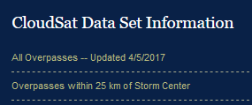

Tropical Cyclone Data Site - http://adelaide.cira.colostate.edu/tc/

Tropical Cyclones – Overpass within 25 km of the eye: http://adelaide.cira.colostate.edu/tc/tcs-25km.txt

From this site you can search for the name of a specific tropical cyclone. Click on the second link to go to the list of overpasses within 25 km of an eye. Look for “Ileana.” From the test list you’ll see a lot of information including the “Granule” Number.

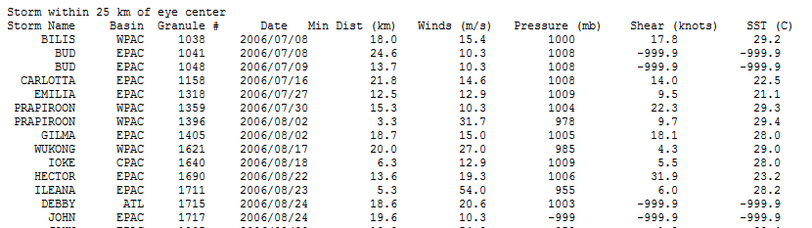

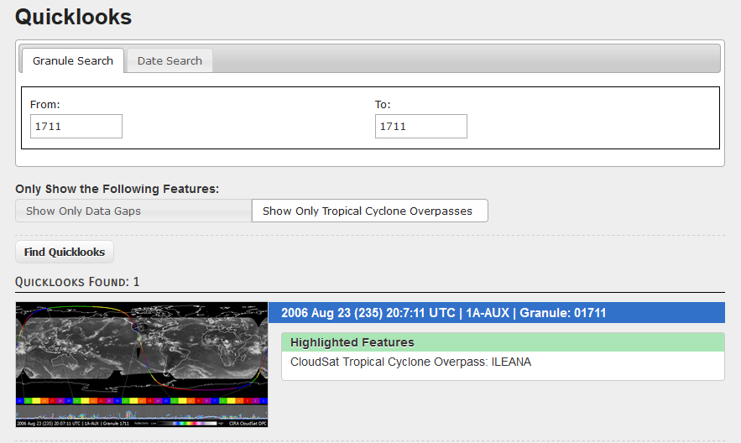
b) Once you know the Granule Number you can search for it on the CloudSat Quicklooks site. Search for Hurricane Illeana 1711 by entering 1711 in both the “From” and “To” boxes. Then click on “Find Quicklooks.” This will make the one Granule where Illeana was passed over pop up as the only option. To open this file click on the image, which will open a larger image into another window. Once you have the full sized Granule you’ll need to select the correct ORBIT TRACK ID to view the tropical cyclone.

Using the Quicklook map find the ORBIT TRACK ID, Start & End Time (UTC) and the Latitude and Longitude Ranges (on the bottom of the images) that show the storm and jot them down (hint: it requires two overpasses to account for the full storm):

FIND THE ORBIT TRACK ASSOCIATED WITH THE OVERPASS: ____________
ORBIT COLOR BAR Number 1: ____________ START TIME: ___________ END TIME: _________
LATITUDE RANGE: ____________ LONGITUDE RANGE: ____________

ORBIT COLOR BAR Number 2: ____________ START TIME: ___________ END TIME: _________
LATITUDE RANGE: ____________ LONGITUDE RANGE: ____________

SAVE THE FOLLOWING IMAGES TO REFERNECE LATER:
1) The overall Granule image with the full orbit
2) The 2B-GEOPROF Radar Reflectivity for both segments that constitute the hurricane overpass.

You will have 4 images from this segment

Hint: You should clearly be able to see the Eye of Hurricane Ileana in one of your 2B-GEOPROF images.

2) Downloading 2B-GEOPROF Radar Reflectivity Data Files
a) You’ll need an account to be able to download data. Go back to the main page (where you selected your Granule and Click on “Login” and select “Create Account.” Follow the instructions.

b) Go back to the main page (where you selected your Granule) and Click on “Order Data” – This will bring you to the Order Data Page.

c) Choose • by Date/Granule - Just Released! From the options. This will open up an new page.
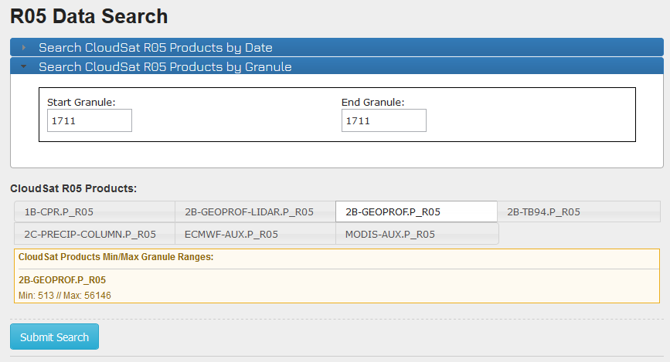

d) As before enter your granule number (1711) in both the Start and End Granule space. Then select the “2B-GEOPROF.P_R05” Product and click “Submit Search.”

This will bring up the granule and you will click “Add to Cart.”

You can then “View your Cart” to go to yet another page where you will click “Submit Order.” This will bring up a completion page that will give you your Order Number and Status. The Status should say “Ready to be Downloaded.” Click on this. It will open a new window and you will need to enter your username and password that you created earlier. Once you enter your information it will bring you to a download page where you can click to download the file and save it to your computer/account.
For your Information File Naming Conventions:

Just like MODIS, CloudSat data products are made available in HDF-EOS format and are created with HDF-EOS 2.5 based on HDF 4.1r2. Files delivered through the online ordering system are compressed (.zip).

2 Matlab Script to Deal with HDF-EOS Swath Data

There are a special set of commands that have been developed ot deal with HDF-EOS Swath data. There are no traditional “Matlab” help functions that you can search for and use. See the above document. See the HDF-EOS Comprehensive Examples page:

http://hdfeos.org/zoo/

a) Start a new script with your regular header. Make sure to start with “clear” at the top.

b) First we need to open the Swath File

clear

% Open the HDF-EOS2 Swath File.
FILE_NAME = '2006235200711_01711_CS_2B-GEOPROF_GRANULE_P_R05_E02_F00.hdf';
file_id = hdfsw('open', FILE_NAME, 'rdonly');

Here you see the file name in purple. For the HDF-EOS files we use the “hdfsw” command which needs the ‘open’, FILE_NAME, and if you are reading or writing. In our case you are only reading so you use the ‘rdonly’ command. You will get the same orange error about hdfsw being removed in future versions. Just ignore it.

c) Next we need to Read the Data from the file. In this case we’re looking at 2B-GEOPROF

% Read data.
SWATH_NAME = '2B-GEOPROF'; % Swath name based on the data type
swath_id = hdfsw('attach', file_id, SWATH_NAME); % Attaching an ID
DATAFIELD_NAME = 'Radar_Reflectivity'; % Identifies the variable
[data, status] = hdfsw('readfield', swath_id, DATAFIELD_NAME, [],[],[]);

>>The last line is formatted as follows:
[DATA,STATUS] = HDFSW('readfield',SWATH_ID,FIELDNAME,START,STRIDE,EDGE)

Reads data from a swath field. FIELDNAME is the string containing the name of the field to read from. START is an array specifying the starting location within each dimension (default is 0). STRIDE is an array specifying the number of values to skip along each dimension (default is 1). EDGE is an array specifying the number of values to write along each dimension (default is {dim- start}/stride). To use default values for start, stride, or edge, pass in an empty matrix ([]). The data values are returned in the array DATA. We are using the default [],[],[].

d) Now we need to take out the other necessary variables (time, lat and lon) and make them double (as usual). Using the default values for start, stride and edge.

% Read lat/lon/height/time data.
[lon, status] = hdfsw('readfield', swath_id, 'Longitude', [], [], []);
[lat, status] = hdfsw('readfield', swath_id, 'Latitude', [], [], []);
[height, status] = hdfsw('readfield', swath_id, 'Height', [], [], []);
[time, status] = hdfsw('readfield', swath_id, 'Profile_time', [], [], []);

% Make type double for plotting.
lat=double(lat);
lon=double(lon);
time=double(time);
data=double(data);

d) Next we need to read in the data attributes using the ‘readattr’ command.

% Read attributes for the Radar Reflectivity including the long name, unit, scale factor, valid range.
[long_name, status] = hdfsw('readattr', swath_id, 'Radar_Reflectivity.long_name');
[units, status] = hdfsw('readattr', swath_id, 'Radar_Reflectivity.units');
[scale_factor, status] = hdfsw('readattr', swath_id, 'Radar_Reflectivity.factor');
scale_factor = double(scale_factor);
[valid_range, status] = hdfsw('readattr', swath_id, 'Radar_Reflectivity.valid_range');

% Read attributes for the Height (y-axis) and the Profile time (x-axis).
[units_h, status] = hdfsw('readattr', swath_id, 'Height.units');

[long_name_t, status] = hdfsw('readattr', swath_id, 'Profile_time.long_name');
[units_t, status] = hdfsw('readattr', swath_id, 'Profile_time.units');

e) After we read in the attributes we need to “detach” the swath id and close the file.

hdfsw('detach', swath_id);
hdfsw('close', file_id);

f) Fill Value and Missing data need to be handled differently for HDF-EOS Swath Files. We use the valid_range attribute and replace values outside the valid range with NaN.

% Process valid_range. Fill value and missing value will be handled by this since they are outside of range values.
data((data < valid_range(1)) | (data > valid_range(2))) = NaN;

g) As with other satellite data we must apply the scaling factor attribute as well.

% Apply scale factor according to [1].
data = data / scale_factor;

h) We’re ready to plot the data and see how it looks. We need to use different figure syntax to deal with the Swath style data. We still need to open a figure panel and we’ll use the “pcolor” function again since the contouring function “contourf” will take too long and look strange. We’ll also use the command “shading flat” to get the characteristic look for the CloudSat Radar Reflectivity. We’ll add units, labels, colorbar and title using new commands as well.

% Create the figure panel.
figure;
pcolor(time, height(:,1), data);
shading flat;

% Put Y-axis label. Where sprintf formats data into a string and the %s is the format specification for setting the data up as a string of characters
unitsh = sprintf('%s', units_h);
ylabel(['Height (' unitsh ')']); % ‘Height’ is text you choose, the unit is from the file

% Put X-axis label.
unitst = sprintf('%s', units_t); % formats the x-axis unit as a string
namet = sprintf('%s', long_name_t); % takes the x-axis name out
xlabel([namet ' (' unitst ')']); % combines the name and unit for the x-axis label

% Draw colorbar.
h = colorbar(); % Adds a colorbar
colormap jet; % Changes the color bar to “jet” which is the rainbow one

% Draw unit.
unit = sprintf('%s', units); % Pulls the unit (dBZe) of the variable
set(get(h, 'title'), 'string', unit, 'FontSize', 12, 'FontWeight','bold')

% Put title.
name = sprintf('%s', long_name); % Pulls the name of the variable out
tstring = {name}; % Turns the name into a text string
title(tstring, 'FontSize', 16, 'FontWeight','bold'); % Add the title

Q1 – (5 points) You should now have a figure that shows the Radar Reflectivity for the entire Granule. Stretch out the x-axis by re-shaping the figure. Save this figure to include with your report. Answer the following questions about this swath figure.
a) What is the x-axis?
b) What problem may the current x-axis format pose for identifying Hurricane Ileana?
c) Are there identifiable cloud features present?
d) Between what altitudes do we find cloud features?
e) Based on the altitudes, and the standard heights for liquid and ice clouds what types of clouds (liquid, ice, or both) are present?

3 MAXIMUM REFLECTIVITY

Before we tackle the x-axis issue we can use the pre-loaded data to find the maximum dBZ value for each vertical profile bin (remember there are 125 vertical bins). Matlab has a handy function called “max” that allows you to specify which dimension you want to find maximum values for.

First we need to know the shape and size of the data array using the ‘size’ function. You can have it print to screen by leaving off the ; at the end, or you can check the values in your workspace. The ‘size’ function returns the information in [row, column] format. Without clearing, type the following into the command line

swath_array_size = size(data)

How many ROWS does the Reflectivity data have: ____________
How many COLUMNS does the Reflectivity data have: _____________

With this information you can now decide which dimension you need to find the maximum values using the max command, described below.
C = max(A,[],dim)

Hint: The above returns the largest elements of matrix A along the dimension dim. Thus, max(A,[],1) returns a row vector containing the largest elements of each column of A, and max(A,[],2) returns a column vector containing the largest elements of each row of A. Here, the required argument [] serves as a divider. If you omit it, max(A,dim) compares elements of A with the value dim and you’ll get a separate curve for every single profile (crazy).

C1 – (5 points) ON YOUR OWN:
a) Based on the help given above add in a line of code that determines the maximum values for each profile level. Use your knowledge of how many levels there are to determine which dimension you need to reference.
b) Once you successfully get an array with a maximum value for each profile layer plot the results (a simple x-y plot) using your new array and your height (y-axis) from your swathplot. Add axes labels and a title.
c) Save this figure to include in your report.

Q2 – (3 points) Answer the following questions about your Maximum Reflectivity figure.
a) What is the maximum value reached for this granule? At what altitude does this value occur? Why?
b) Based on your identification of cloud features (altitudes from Q1) what is the average reflectivity of the cloud features?

4 X-AXIS and SUB-SETTING DATA (to find Hurricane Ileana)

a) Time – Assessing the Time Array and UTC Time Stamps from Quicklook.

Q3 – (10 points) Answer the following questions about the way time is formatted.
a) How large is the time array (e.g. number of rows and columns)
b) Based on this array size, how many profiles are included in the Granule?
c) In Matlab Click on the array so it displays the values in the variable window. What do the values you see tell you about the length of time between profiles?
d) Since the x-axis label states “seconds since start the start of the granule,” how many profiles are recorded per second?
e) If time zero is the start time of the Granule that means it corresponds to the UTC start time that can be found on the Quicklook Granule. What is the start time of the Granule in UTC time?
f) What is the start time of the first Granule chunk containing Hurricane Ileana?

Hint: The satellite is traveling UP, your orbit tracks go in number order and the images are viewed from right to left (as you go UP the orbit track).

g) Using the information found above, what row in the time array corresponds to the start time of the first Granule chunk containing Hurricane Ileana?

Hint: You’ll need to figure out how many seconds elapsed between the start of the full granule and the start of the segment you are interested in and then take into consideration the length of time each profile represents. (row 1 = the start at 0 seconds)

h) What row in the time array represents the end time of the second Granule chunk containing Hurricane Ileana?

Hint: You’ll need to figure out how many seconds elapsed between the start of the granule with Hurricane Ileana and end of the second chunk, then take into consideration the length of time each profile represents.

Once you have the start time row and end time row for the hurricane feature you can use it to “zoom in” on that particular section in the Swath data.

5 MODIFYING THE FIGURE CODE TO ZOOM IN ON (HURRICANE ILEANA)

a) For the HDF-EOS data you can use your information about the time variable to choose the region to focus on for the x-axis. See below for the structure and use the row values you identified in steps g) and h) above. Modify your script accordingly.

figure;
x = data(:,time_start:time_end); % time_start and time_end are row numbers
t = time(time_start:time_end); % sets the variable t based on your row IDs
pcolor(t, height(:,1), x) % makes the figure, time, height, and data.
shading flat; % formats the figure to look like CloudSat
colormap jet;

b) You should now have a new figure that only shows the two Granule subsets that went over Hurricane Ileana. Answer the following questions below about this new figure

Q4 – (14 points) Answer the following questions about the new subset:
a) The Eye: At what time (seconds since the start of the Granule) is the eye located? Using your method from above (in reverse) what UTC time does this correspond to?
b) Using the Maximum Reflectivity code from above as an example, determine the maximum reflectivity within this subset.

Hint: You’ll need to specify the same row segment of the “data” array.
data(:,start_row:end_row)

c) What do these regions of high reflectivity (yellows and oranges) represent?
d) You will notice, as with the full Granule, the high reflectivity near the surface. Underneath Ileana this high reflectivity disappears. What might be the cause of this?
e) Based on your knowledge of hurricane structure, what is the likely composition of the lighter blue and darker blue reflectivity values in the upper portion of the hurricane, e.g. (liquid or ice)? What typical hurricane feature would these reflectivity values represent?

Next: Using the Matlab “Show Plot Tools and Dock Figure” Button Change the X-Axis
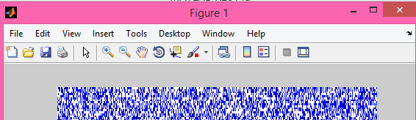
Next: Double Click on the x-axis to open up the axis editor. Change the X-limits, highlighted in yellow below, until you have zoomed in successfully on the desired features. Use these values to help you answer the questions below:

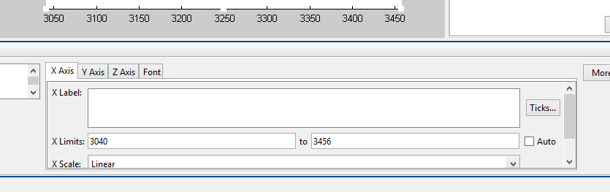

f) Hurricane Diameter Estimation: Estimate the number of seconds in the scan associated with Hurricane Ileana. Based on your knowledge of the sensor and its scanning horizontal resolution (readings and lecture notes), determine an approximate diameter (in km and miles) for Hurricane Ileana. What is the average diameter of a tropical cyclone? Is your estimation of Hurricane Ileana’s diameter reasonable in comparison?
g) Hurricane Eye Diameter Estimation: Zooming in farther, as needed: determine the approximate size of the eye in km. How does your approximation of eye diameter compare to the maximum estimated diameter of 23 km.

6 PLOTTING THE GROUND TRACK (Map View)

With each lab it is good to gain experience plotting similar data (in this case a map view) in a slightly different way. Here we’re going to use the “axesm”, “setm” and “plotm” functions to make a figure that shows the ground track for our Hurricane Ileana pass using a Mercator projection.

For this exercise you will need to determine the ideal latitude and longitude to focus on this event. You can use MODIS L1 Granules (legacy image search from previous lab) from lab one to find the actual MODIS Granule to identify the ideal lat and lon. Or, you can guess by trial and error. ☺

a) Set your lat and lon limits ahead of time (will be actual latitude and longitude numbers):

latlim = [lat_min lat_max]; % Set your own to optimize your view of the overpass
lonlim = [lon_min lon_max]; % Set your own to optimize your view of the overpass

b) Something new, setting the figure background color (this also makes the figure exist).

figure('Color','white')

c) Using the ‘axesm’ function
axesm(PropertyName,PropertyValue,...) creates a map axes using the specified properties. Properties may be specified in any order, but the MapProjection property must be included. For us we’ll be using the ‘mercator’ projection. We’ll also be including a different way to load the coastline file . See below and use matlab help for clarification.

axesm('mercator','MapLatLimit',latlim,'MapLonLimit',lonlim, ...
'Frame','on','Grid','on','MeridianLabel','on', ...
'ParallelLabel','on')
axis off % turns off automatic axes
setm(gca,'MLabelLocation',60) % sets the location of the lat/lon labels
coast = load('coast.mat'); % loads the coastline file
plotm(coast.lat,coast.long, 'k') % plots the coastline in black
hold on % tells matlab to wait for more data

d) Adding your CloudSat Track.
Use “plotm” for your track in the same way as the coastline data, except this time you’ll need to specify which rows of the lat and lon file you want to plot. These are the SAME lat and lon row values that you used before to identify the Granule subsection surrounding Hurricane Ileana in Q3 g) and h). Add a line of code to plot this subset, color it red and change the line width to “5”. It will have the format below where “start” is the start row number of the granule subset and “end” is the send of the granule subset, colorid is the color code (e.g. r, k, b, c) and ‘thickness’ is the number of points you want the line to be (start and end refers to the row numbers from before):

plotm(lat(start:end), lon(start:end),'colorid', 'LineWidth', thickness)

e) Finishing touches – Title and Markers

We can easily add a title like we have in the past. You can also add a text marker to show where the granule subset starts and finishes, it helps you identify if the satellite was on an ascending or descending orbit.

i) Add a Title to your figure.

ii) Add text markers by following the example below. Note the “. . . “ allows you to continue your line of code over more than one line. Also, you can specify the font size, weight and color. For the “textm” function you have to specify the color using the full word. To mark the start location and end location use the row numbers from the previous steps. Note “start” and “end” refers to the start row number and end row number.

textm(lat(start), lon(start), '*', 'FontSize', 16, 'FontWeight','bold', ...
'Color', 'green');
textm(lat(end), lon(end), '*', 'FontSize', 16, 'FontWeight','bold', ...
'Color', 'red');

iii) Save your figure to include in the lab write up. You should have a black and white map with black coastlines, dashed gridlines, a thick red line with two asterisks.

7 LAB REPORT WRITE UP

Provide the following in digital format by Friday, October 6th, 2017:

1) (5 points) A brief summary/conclusion of the labs main goal and breif discussion about the CloudSat satellite’s strengths and weaknesses.
2) (13 points) Coding question C1 and Figures (2 points per figure)
a) Full Granule Radar Reflectivity
b) Full Granule Maximum Reflectvitiy with Height
c) Hurricane Ileana Radar Reflectivity
d) Map with CloudSat Track
3) (32 points) Inerpretation questions Q1 through Q4

