ATMO 611 – Satellite Data Applications Lab Assignment #7

50 Points Total Available

Revisiting Historical Biomass Burning in South America – DUE Tuesday December 12th, 2017

This lab will give you some experience with MODIS Fire Products and allow you to compare these data with the MODIS Dark Target Deep Blue Data. You’ll be making time series, and scatter plots to compare the MODIS Active Fire data to the MODIS Aerosol Data. You will learn how to make a “Matlab Data Movie” and calculate correlation coefficients and best fit lines. Questions to be answered are labeled Q1, Q2, etc. and are highlighted in Red. More guidance will be provided as to how detailed a response I am expecting for each question or the specificity of the answer. Matlab coding on your own are highlighted in Green as C1, C2, etc.

1 DOWNLOADING MODIS DTDB and MODIS FIRE COUNTS

1) Download MODIS daily L3 global aerosol data.

You can use the same methods we’ve used in previous Lab 4, except this time we want Monthly Data for 2006-2008. You’ll need all the days between 1-1-2006 and 12-31-2008.

GET THESE L3 HDF FILES using LAADS Web: https://ladsweb.modaps.eosdis.nasa.gov/search/

- MODIS: Aqua → 6-MODIS Collection 6 → L3 Atmosphere Product [3] → MYD08_M3 MODIS/Aqua Aerosol Cloud Water Vapor Ozone Monthly L3 Global 1Deg CMG.
- Temporal Type: Just use the regular option but type in 2006-01-01 and 2008-12-31
- Location: World (Default if nothing else is selected)
- Files: Download each of the 36 files. This will take time since they are ~400 MB a piece!

2) Next you need to download and the MYD14CM1 product:

1) We’re going to get our data through a slightly different channel:

http://modis-fire.umd.edu/pages/ActiveFire.php?target=GetData

Once there click on the “http://reverb.echo.nasa.gov” This will bring you to the Reverb site. From there it’ll ask you to try the new “Earthdata Search” in the upper right hand corner where it says “Search Terms” click on the “Try out this query in Earthdata Search”

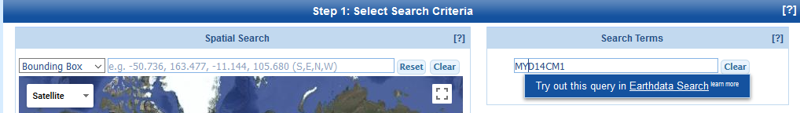

Once on the new Earthdata site it type in “MYD14CM1” into the search bar. This gives you the MODIS/Aqua 1 degree Gridded MODIS Active Fire Product for Collection 5. It is not yet available for Collection 6 so we’ll have to make do with the older version.
2) Next to where you typed “MYD14CM1” there is a small clock. Click on this to choose your time range. Enter the same time range you used for the L3 Aerosol Data (2006-01-01 to 2008-12-31). This wil change the information on the bottom of the page from 162 granules to 36. When it says “36 Granules” it just means 36 months of data. It should look like the image below when you’re ready for the next step. Click on the panel →
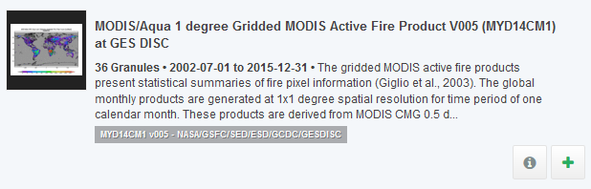
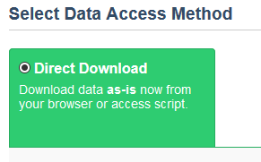
3) It will then open up a panel with each of the different files. Click on the Green “Download Data” Button it will ask you to log in with your EarthData login. I choose to click on the “Direct Download” link on the lower right hand corner. This will take you to a page full of downloadable links. You can use “Down Them All” or just click on them individually.

4) If you don’t want to do it this way you can download the files using the little icon with the arrow on each individual file.
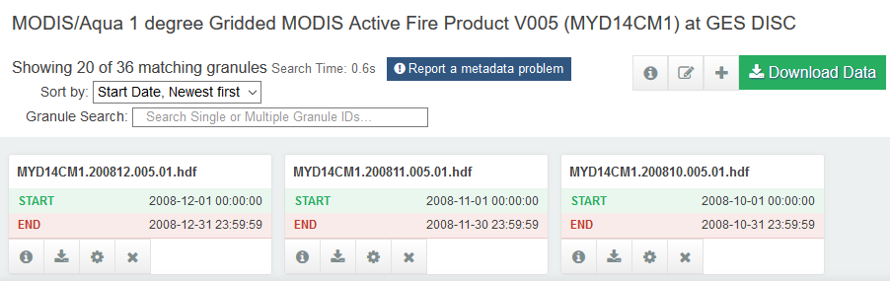

Q1 – (9 points) Land Data Format:
a) (1 pts) The MYD14CM1 is global gridded data. How is this different than the L2G Land Data?
b) (2pts) Describe the Integerized Sinusoidal Grid, include an image/diagram, How is this different than the gridded (mapped) data? Use the readings and lectures to help you provide a thorough description.
c) (2 pts) Which wavelengths are used in the generation of the Fire Products? Which area of the electromagnetic spectrum are these wavelengths located?
d) (4 pts) Describe what the MYD14CM1 product actually provides. There are 4 variables included in each HDF file. Provide a brief description of each. Use Google or the ReadMe file that is downloadable with the actual data.

3) Extract the Fire Count Variable and make a VIDEO of the monthly data!

These files include 4 different variables. You’re going to extract the “CloudCorrFirePix” variable. This is the “Cloud and Overpass Corrected Fire Pixel Count,” which is unitless. It is 180 x 360, so the same 1 x 1 degree latitude and longitude format that the MODIS DTDB data is in. You can use the same 1 x 1 degree MODIS latitude and longitude files you’ve used before. Check that the orientation of the map is ok if you want to make sure, though since you’ve been dealing with MODIS data before, you can make an assumption.

C1 – (10 points) ON YOUR OWN CODE:
a) Extract the CloudCorrFirePix variable and save the 36 files. Make sure to name the files including the year and month. You’ll need those later for making the timeseries plots.
b) While you are extracting the data files using an automated loop you can add in a quick bit of code to turn a series of plots into a video. Within the loop, after you save the files include code to produce a figure. Use a colorbar axis of 0-100 ( caxis ([0 100]) ). And use the colormap ‘hot’ and make the outlines of the continents white ‘w’ instead of our usual black ‘k’.
c) You will also need to add in some code to include a text annotation noting for month is being shown in each figure (so you can track the monthly changes in fire activity). See the code below. Include this code after you add in the axes for latitude and longitue:

% Add a text box with the month
if month == 1
text(-30,-50,'\bf \fontsize{15} \color{white} JAN'); %
elseif month == 2
text(-30,-50, '\bf \fontsize{15} \color{white} FEB');
elseif month == 3
text(-30,-50, '\bf \fontsize{15} \color{white} MAR');
elseif month == 4
text(-30,-50, '\bf \fontsize{15} \color{white} APR');
elseif month == 5
text(-30,-50, '\bf \fontsize{15} \color{white} MAY');
elseif month == 6
text(-30,-50, '\bf \fontsize{15} \color{white} JUN');
elseif month == 7
text(-30,-50, '\bf \fontsize{15} \color{white} JUL');
elseif month == 8
text(-30,-50, '\bf \fontsize{15} \color{white} AUG');
elseif month == 9
text(-30,-50, '\bf \fontsize{15} \color{white} SEP');
elseif month == 10
text(-30,-50, '\bf \fontsize{15} \color{white} OCT');
elseif month == 11
text(-30,-50, '\bf \fontsize{15} \color{white} NOV');
elseif month == 12
text(-30,-50, '\bf \fontsize{15} \color{white} DEC');
else
end

The text annotation style specifiers are: \bf = boldface, \fontsize{15} = size 15 font, and \color{white} = color, and then the text (e.g. AUG) is what will actually show up on the figure.

IMMEDIATELY after you finish your figure section, but before you end your loop, add in the following line of code (note that “n” is my counter for my loop, you may have another letter):

fire_video(n) = getframe; % "n" is the counter for your loop

Now, after you finish your loop add the next two lines of code.

movie(fire_video,2) % Play the movie two times
movie2avi(fire_video,'MODIS_Fire_2006-2008_Griswold.avi','compression','None','fps', 0.5);

This lets you see the video play through twice right away. The second line saves the file as an avi file. The parameter ‘fps’ is the frame per second. I’ve set it to 0.5 so I have enough time to look at the individual plots before they change, though you could set it to a different value. The default is 15 which is a little fast:

Your figure code will produce 36 figures and the video. I know that seems a lot, but “getframe” needs to screen capture each figure to save it in the video file.

c) ONLY save the video. Do not save the individual monthly figures. Include the .avi video file with your lab by either sending it by email OR bringing it to me on a flash drive. Note the video does not save the axes or the color bar. That’s ok, it takes a LOT more code to get it to capture everything.

Q2 – (5 points) Three years of Fire Data – Movie Interpretation: You should have 36 months of fire data. Watch the video through a few times.
a) (1 pt) Which region(s) of the Earth show high fire counts during Dec-Jan-Feb?
b) (1 pt) Which region(s) of the Earth show high fire counts during Sep-Oct-Nov?
c) (1 pt) Which region(s) of the Earth show high fire counts during Apr-May?
d) (2 pts) What causes this seasonal shift in fire activity?

2 MONTHLY TIMESERIES OF FIRE and AEROSOL

Now you get to use your expert time series and regional selection skills from previous labs. All of the data files are already in 1 x 1 degree monthly format so the comparison will be easier than if you had to convert file resolutions.

C2 – (5 points) ON YOUR OWN CODE:
a) Extract Monthly Dark Target Deep Blue Aerosol Optical Depth data for the 2006-2008 MODIS Aerosol Data. Use your code from Lab 4 to help you out (variable name: DTDB_550_Dark_Target_Deep_Blue_Combined_Mean_Mean).
b) Write code to save these files in .csv format. You will have 36 files when you’re done. The same number files as the MYD14CM1 data.
c) Once you’ve created the monthly files copy or transfer the all the monthly DTDB files into one folder with the 36 MODIS Fire Count files so they can be read easily by the same code. Now you are ready to calculate the timeseries plots.
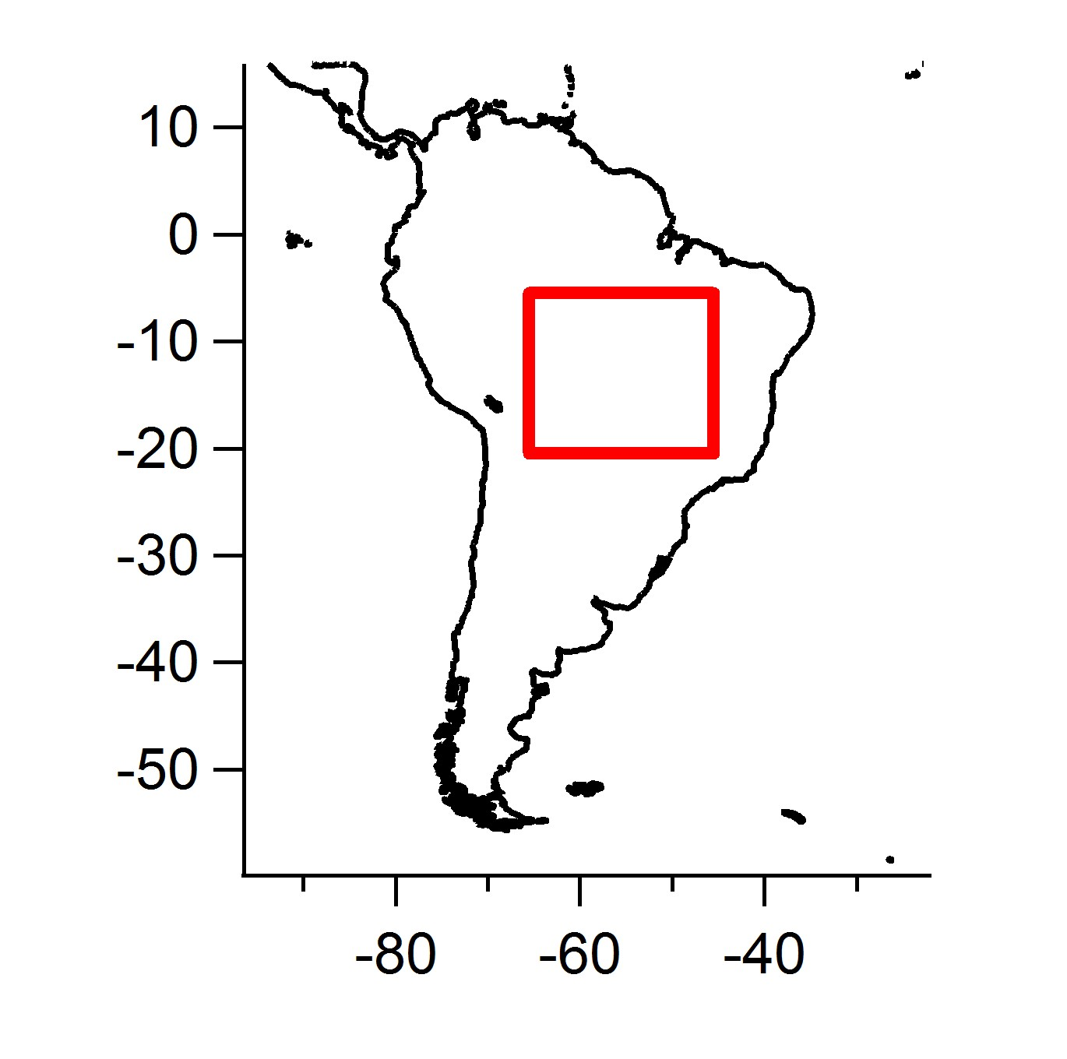
2) Time series preparation for South America

You’re going to use the same box that you used from Lab 4 since this box was identified in 1 x 1 degree (180 x 360) format. This way you know that your box corners will work and that you’ll be able to pull out the information to produce the time series figure. We want to compare the amount of fires with the DTDB for our South American region of interest.

i) Region: South American Box (This corresponds to -5.5° to -20° Latitude, -65.5° to -45.5° Longitude)

C3 – (5 points) Make a figure with TWO time series curves:
a) Follow the same proceedure as Lab 4 for automating the calculation of regional averages from specified latitude and longitude boxes for MODIS DTDB and the FIRE COUNTS and save in their own array with (36 rows, 4 columns – year, month, mean, stdev). Below is an example of the lat-lon box corners from my code and the set up for the timeseries storage files.

HINT: You’ll have to include two loops, one for MODISdir = dir(‘MODIS_STDB*.csv’); and one for MODISdir = dir(‘MODIS_Fire*.csv’); Do the DTDB one first and then do the FIRE COUNT one after. There are four columns in the timeseries arrays (year, month, mean and standard deviation).

% Boundaries for Zoomed in Box in South America
% finds the index location in the original lat file for the right latitudes
% finds the index location in the original lon file for the right longitudes
BRZ_box_zoom_top_center_lat = find(MODIS_Lat(:,1) == -5.5); BRZ_box_zoom_bottom_center_lat = find(MODIS_Lat(:,1) == -20.5); BRZ_box_zoom_left_center_lon = find(MODIS_Lon(:,1) == -65.5); BRZ_box_zoom_right_center_lon = find(MODIS_Lon(:,1) == -45.5);

%~~~~~~~~~~~~~~~~~~~~~~~~~~~~~~~~~~~~~~~~~~~~~~~~~~~~~~~~~~~~~~~~~~~~~~~~~~
% Finding the number of files in the directory
MODISdir = dir('MODIS_DTDB*.csv');
num_months = length(MODISdir);
%
% Making an empty array to store the year, month, mean, and standard deviation for a total of three columns
%
BRZ_DTDB_timeseries_file = zeros(num_months, 4); % for MODIS DTDB
%
% FILE NAME STRING
MODIS_DTDB_BRZ_Save_String = 'All_MODIS_DTDB_BRZ'; % Save String
%
%~~~~~~~~~~~~~~~~~~~~~~~~~~~~~~~~~~~~~~~~~~~~~~~~~~~~~~~~~~~~~~~~~~~~~~~~~~

c) Make a figure showing the full 2006-2008 36-month data set including both the MODIS DTDB and the MODIS FIRE COUNT. Make two curves, one showing the MODIS DTDB and the other for MODIS FIRE COUNT data. You’ll also need to use “plotyy” so that you can see both the DTDB and the FIRE COUNT on the same x-axis see help below:

You should now have a single plot with the monthly times series for MODIS DTDB and MODIS FIRE COUNTS. The plotting code above gives you a plot with TWO y-axes so you can view dissimilar data for the same time frame (month/year on the x-axis).

Q3 – (5 points) Timeseries Analysis Questions
a) (1 pt) Which of the three years has highest MODIS DTDB and MODIS FIRE COUNT values?
b) (1 pt) Which of the three years has the lowest MODIS DTDB and MODIS FIRE COUNT values?
c) (1 pt) For the maximum year, what month does it occur? What are the values for DTDB and FIRE COUNT for this month?
d) (1 pt) For the minimum year, what month does it occur? What are the values for DTDB and FIRE COUNT for this month?
d) (1 pt) Overall, does it appear that MODIS DTDB and FIRE COUNT are well correlated?

3 CORRELATION OF MODIS DTDB AND FIRE COUNT

For this last portion of the lab we’ll be calculating the correlation coefficients between the MODIS DTDB data and the MODIS Fire Count data. You’ll simply be using the time series data that you produce and discussed in section two.

1) Add code at the end of your time series file. This will create the scatter plot between the mean monthly MODIS DTDB and the MODIS Fire Count Data

C3 – (5 points) Here you’re going to create a scatter plot and determine the correlation bewteen the data:
a) Add code at the end of your time series script to create a scatter plot bewteen the mean monthly MODIS DTDB and the MODIS Fire Count Data. This is very straight forward.
b) Add a fit to the data and calculate the R^2. Use the code below to add the fit line and to have the R^2 sent to the screen (in your Matlab Command Window). Using the example from the MODIS Fire maps (for the video) add in a text annotation on your scatter plot to display the R^2 vaule.
c) Make sure to add a legend including the data and the fit.

coeffs = polyfit(xx, yy, 1); % returns the coefficients for a least-squares best fit
R = corrcoef([xx,yy]);
R(1,2)^2 % Calculates the R^2 value and prints to the screen.
% Get fitted values
fittedX = linspace(min(xx), max(xx), 200);
fittedY = polyval(coeffs, fittedX);
% Plot the fitted line
hold on;
plot(fittedX, fittedY, 'k-', 'LineWidth', 1.5); % Adds the fit line, black, 1.5 thick

Q4 – (3 points) Correlation Questions
a) (1.5 pt) Based on your scatter plot and R^2 value do you feel confident in saying that MODIS DTDB and MODIS Fire Counts are related? Explain why the relationship makes sense from a physical standpoint.
b) (1.5 pt) There is an outlier that has much higher DTDB and FIRE values. Do you think the correlation will change significantly if you removed that data point? Why or why not?

7 LAB REPORT WRITE UP - Provide the following in digital or paper format by Friday, April 3rd, 2015:

1) (2 points) – A brief summary/conclusion of the labs main goal.
2) (25 points) – Coding questions C1-C4 Video, and Figures (2 in total)
3) (22 points) – Science/Interpretations Question Q1, Q2, Q3, and Q4
4) (1 point) – emailing code

