ATMO 611 – Satellite Data Applications Lab Assignment #9

50 Points Total Available

California Drought – Nominally DUE Wednesday November 29th 2017

This lab will give you experience with the V2.3 GPCP Monthly and Monthly Climatological data sets along with TRMM Data. We’ll be comparing the two datasets (with different resolutions) to see how well they agree. You’ll also practice switching the configuration of the map in a “quick and dirty” way as well as calculate anomalies and normalized anomalies for precipitation. Questions to be answered are labeled Q1, Q2, etc. and are highlighted in Red. More guidance will be provided as to how detailed a response I am expecting for each question or the specificity of the answer. Matlab coding on your own are highlighted in Green as C1, C2, etc.

1 DATA ACQUISITION AND PREP

We’ll need to download data from three different satellite systems for this lab. We’ll be getting GPCP monthly mean precipitation (2.5° x 2.5°), GPCP climatological average (2.5° x 2.5°), TRMM (0.25° x 0.25°).

1) Downloading GPCP Data

We’ll get the GPCP Data set first. This is the easiest and most straight forward of the data sets to acquire and process. Go to the following link to easily download the NetCDF files:

http://www.esrl.noaa.gov/psd/data/gridded/data.gpcp.html

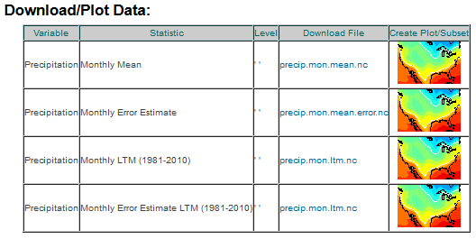
Make sure you’re looking at the “GPCP Version 2.3 Combined Precipitation Data Set (Final) page. Scroll down so that you see the “Download/Plot Data:” section. You’ll need to download:

a) “Monthly Mean” statistic with the file name: precip.mon.mean.nc

b) “Monthly LTM (1981-2010)” statistic with the file name: precip.mon.ltm.nc

You should have two files one that is ~15.2 MB and one that is 734 kb.

Use Panoply, ncdump or any other way of looking into the metadata to find the correct way to extract the data later on in the lab.

2) Downloading TRMM Data

We need both TRMM and GPCP because they provide precipitation estimates at different resolutions. We’ll be looking to see how well GPCP and TRMM agree over region that includes California and the Pacific Coast. To download the data we’re going to our favorite NASA data site “MIRADOR”! Here are a lot of helpful comments about the status of the TRMM mission and its termination.

http://mirador.gsfc.nasa.gov/cgi-bin/mirador/presentNavigation.pl?project=TRMM&tree=project
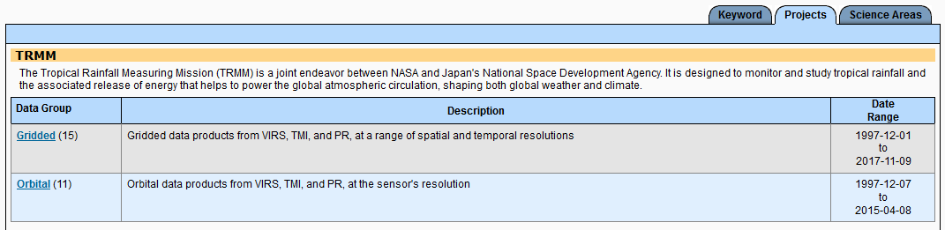
This brings you to the TRMM page at MIRADOR. Scroll down until you see the entry for the 3B43 product which is the Monthly 0.25 x 0.25 degree merged TRMM and other sources estimates.

The 3B43 dataset is the monthly version of the 3B42 dataset. This product is created using TRMM-adjusted merged microwave-infrared precipitation rate (in mm/hr) and root-mean-square (RMS) precipitation-error estimates. It provides a ‘best’ precipitation estimate in a latitude band covering 50°N to 50°S, an expansion of the TRMM region, from all global data sources, namely high-quality microwave data, infrared data, and analyses of rain gauges. The granule size is one month.

Once you are linked to the Mirador ordering site Click on “Spatial and Temporal Search”

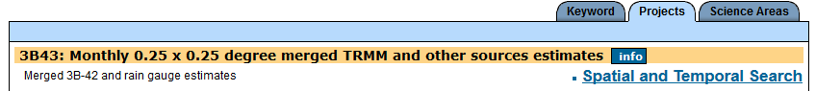

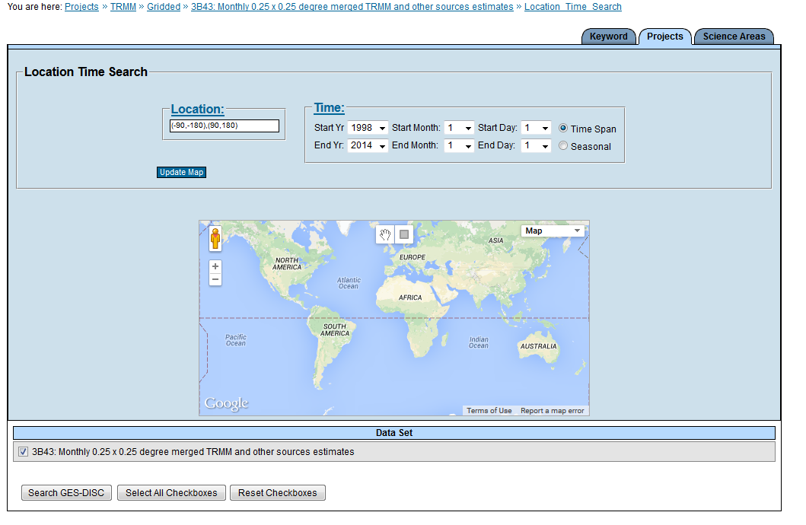
This will bring you to the spatial and temporal search page. Change the end month to “10” and then Click on the “Search GES-DISC” in the bottom left hand corner.

This will get you data from
Jan 1998-Aug 2017

Once you click on it you can add all the files to your cart like normal.

There should be 236 files.

You have a variety of options on the “Basic Download” page if you’re used to using UNIX or other command prompt languages. If not, you can click on the “More Download Options” tab and then select the “down THEM all!” Option by clicking on the “URL Listing Page” Link.

It will take a bit of time since they are about ~4 MB a piece. I had some problems with “Down Them All” asking for a username and password and this caused specific file downloads to fail. So, many files weren’t downloaded the first time around. It took a while to get all the files. Be wary of this if you use “Down Them All.” But, I think if you’re already logged in to the Earthdata site then it doesn’t ask you for the password.

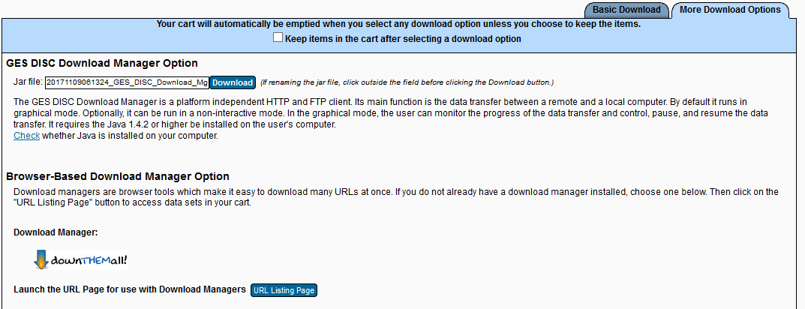

Note: Some files have a different Data version identification “7” or “7A.” The 7A files are from 2000-2010. See the note below:
3B43.20100901.7A.HDF vs. 3B43.19990701.7.HDF

“Important Changes: After the initial Version 7 processing, it was discovered that AMSU data were neglected in the first retrospective processing of both the Version 7 TMPA (3B42/43) and TMPA-RT (3B40/41/42RT) data series, which created an important shortcoming in the inventory of microwave precipitation estimates used during 2000-2010. In addition, a coding error in the TMPA-RT replaced the occasional missings in product 3B42RT with zeros. Accordingly, both product series were retrospectively processed again. The main impact in both series was to improve the fine-scale patterns of precipitation during 2000-2010 (and for 3B4xRT into late 2012). Averages over progressively larger time/space scales should be progressively less affected. [This is the reason the lack of AMSU went undiscovered; the merger system copes very reasonably with missing data.] Nonetheless, users are urged to switch to the newest Version 7 data sets. The newest runs may be identified by the file names: V.7 3B42/43 suffix of "7A.HDF" for January 2000 - September 2010; V.7 3B4xRT suffix of "7R2.bin" for 1 March 2000 - 6 November 2012. It continues to be the case that the Version 7 3B42/43 is some 4% higher than the calibrating data set (2B31) over oceans, which is still under study. However, the initial conclusion is that it results from the sampling mismatch between the (very sparse) TCI and the (much denser) microwave constellation. At the large scales this offset seems to be nearly a proportional constant.”

2 DATA EXTRACTION AND ORIENTATION CHECKS

You are all experienced with extracting variables from various formats of data. Note that you’ll need to use two different methods to deal with the data sets in this lab.

a) GPCP Monthly Climatology is in NetCDF – All the Months in one file (1981-2010)
b) GPCP is in NetCDF format – All the Months in one file (Jan 1979 – Oct 2017)
c) TRMM is in HDF format – Each month is its own file (Jan 1998 –Aug 2017)

C1 – (5 points) GPCP Climatological Files: Extracting the data and checking map orientation
a) Extract Just the January and July data files from the Climatological GPCP data into “.csv” files.

Hint: It is standard netCDF so go look back at your MODIS SST code and use that for inspiration.

Hint: Always start with extracting a single matrix (say January from the climatology files) to make sure you know the orientation of the GPCP arrays and how to manipulate it. It’s up to you to extract the variable.

Hint: These data have the Pacific Ocean in the center. You’re going to learn thow to re-map this using a quick trick of splitting and re-concatinating the matrices. See below on how to flip, and reorient the data array to make the Matlab figure function happy:

% Fix the January Map
rot90_GPCP_C_Jan = rot90(GPCP_C_Jan_double,3); % rotates my doubled Jan array by 270 deg
flip_rot90_GPCP_C_Jan = fliplr(rot90_GPCP_C_Jan); % flips around vertical axis
First_Half_GPCP_Jan = flip_rot90_GPCP_C_Jan(:,1:72); % Take the first half
Second_Half_GPCP_Jan = flip_rot90_GPCP_C_Jan(:,73:144); % take the second half
GPCP_C_Jan_New = [Second_Half_GPCP_Jan, First_Half_GPCP_Jan]; % Atlantic Ocean Center
dlmwrite('GPCP_Clim_01.csv', GPCP_C_Jan_New,'delimiter',',','precision',15);

Hint: The latitude and longitude arrays that are included with the GPCP data only match the Pacific Ocean centered data. Below is a new set of Lat and Lon arrays that you can use (at the correct resolution) to make your figures that match with the flipped, rotated and Atlantic Ocean centered data from step a). Feel free to make your own using another method if you choose.

% This gives you a set of Lat and Lon arrays at 2.5 resolution for Atlantic Centered Data
%
GPCP_Lon = [-178.75:2.5:178.75]'; % This is in the correct alignment
GPCP_Lat_updown = [-88.75:2.5:88.75]'; % This is upside down (S on top of N)
GPCP_Lat = flipud(GPCP_Lat_updown); % flipud "flips" the array upside down
%

b) Make a Figure for the Climatological January Data (1981-2010) and include it with the lab write up. Make sure to include a title, axes labels, and a color bar (use the same for January & July).

c) Make a Figure for the Climatological July Data (1981-2010) and include it with the lab write up. Make sure to include a title, axes labels, and a color bar (use the same for January & July).

Q1 – (5 points) Comparison of January and July Global Climatological Maps:
a) (2.5 pts) January – Where is precipitation highest in the Pacific? In the Atlantic? What land regions show a high precipitation rate? Estimate the precipitation rate (mm/d) over the Coastal California Region using the Matlab cursor.
b) (2.5 pts) July – How has the map changed from January? What is the dominant feature of the July map that was not present in January? How does precipitation change between January and July in the West Pacific? Estimate the precipitation rate (mm/d) over the Coastal California Region using the Matlab cursor.

C2 – (5 points) Practice GPCP Monthly Data Extraction and Comparison to Climatology
a) (1 pt) First, extract two specific months from the GPCP monthly data. You will be extracting January 1998 and July 2014 as practice and to compare with the climatological January data and Climatological July Data.

Hint: For the Monthly data you’ll have to figure out which matrix in the set off matrices is associated with January 1998 and January 2014. Keep in mind that there are 464 files from January 1979 – August 2017 . January 1979 = 1 and August 2017 = 464. See example below where “14” is the way you designate that you want to remove the “14th” matrix which is February 1980:

GPCP_M_Feb_1980 = double(GPCP_M_data_1(:,:,14));
dlmwrite('GPCP_Raw_1980_02.csv', GPCP_M_Feb_1980,'delimiter',',','precision',15);

b) (2 pts) Continue to process the data and prepare two figures, one for January 1998 and one for January 2014.
i) Produce an additional figure for later: Using the January 1998 data, zoom in to the Western Coast of the US approximately 50 N-32 N Latitude and -128 to -124 Longitude. We’ll be using it later with TRMM.

Hint: The code above only takes out the RAW (then doubled) data from the main NetCDF file. You’ll still need to use the “split, flip and rotate” code that you used for the climatologic data.

c) (1 pt) Using the January Climatology data file from C1 and the data above for January 1998 prepare a figure to show the difference between January 1998 and the January Climatology. Save this figure for your lab write up.

d) (1 pt) Using the January Climatology data file from C1 and the data above for July 2014 to show the difference between July 2014 and the July Climatology. Save this figure for your lab write up.

Hint: If you fixed your color bar you’ll need to change it to accommodate negative values.

Q2 – (5 points) Comparisons to Climatology
a) (2.5 pts) Since we’ll be commenting on California precipitation later on, discuss precipitation in California for 1998 in comparison to the climatological mean. What historical event can be related to the patterns you observe?
b) (2.5pts) How does precipitation in California in July 2014 compare to the climatological mean. What current situation can be linked to this pattern?

3 GPCP CALIFORNIA TIMESERIES and ANOMALIES

Now that you know your maps are the correct orientation and you’ve looked into the files a bit (and are able to identify specific months) we can look at the full 464 month time series of precipitation for the California Region.

a) First you’ll need to extract and save ALL of the months and split, flip and rotate the arrays so that you know your arrays are in the correct orientation. There are a multitude of ways to extract all 464 months of data.

I chose to write one long, yet simplistic, code to extract each individual month and save the “double” file and then use a separate looping code to automate the data rotation and fixing the oceans. It’s not elegant, but it guaranteed that I had the correct month saved with the correct name.

Below is an excerpt from the beginning of my long simple code including 1979. First you need to open the file and then do the “NetCDF thing” to identify variables:

%~~~~~~~~~~~~~~~~~~~~~~~~~~~~~~~~~~~~~~~~~~~~~~~~~~~~~~~~~~~~~~~~~~~~~~~~~~
ncid_1 = netcdf.open('precip.mon.mean.nc','NOWRITE');
%
%~~~~~~~~~~~~~~~~~~~~~~~~~~~~~~~~~~~~~~~~~~~~~~~~~~~~~~~~~~~~~~~~~~~~~~~~~~
%
time_id_1 = netcdf.inqVarID(ncid_1,'time'); % identifies the time variable
datatime_1 = netcdf.getVar(ncid_1, time_id_1); % uses id to bring into matlab
%
GPCP_M_id_1 = netcdf.inqVarID(ncid_1,'precip'); % identifies the data variable
GPCP_M_data_1 = netcdf.getVar(ncid_1,GPCP_M_id_1); % uses id to bring into matlab
%
% GPCP 1979 Monthly Data (1-12)
GPCP_M_Jan_1979 = double(GPCP_M_data_1(:,:,1));
dlmwrite('GPCP_Raw_1979_01.csv', GPCP_M_Jan_1979,'delimiter',',','precision',15);
GPCP_M_Feb_1979 = double(GPCP_M_data_1(:,:,2));
dlmwrite('GPCP_Raw_1979_02.csv', GPCP_M_Feb_1979,'delimiter',',','precision',15);
GPCP_M_Mar_1979 = double(GPCP_M_data_1(:,:,3));
dlmwrite('GPCP_Raw_1979_03.csv', GPCP_M_Mar_1979,'delimiter',',','precision',15);
GPCP_M_Apr_1979 = double(GPCP_M_data_1(:,:,4));
dlmwrite('GPCP_Raw_1979_04.csv', GPCP_M_Apr_1979,'delimiter',',','precision',15);
GPCP_M_May_1979 = double(GPCP_M_data_1(:,:,5));
dlmwrite('GPCP_Raw_1979_05.csv', GPCP_M_May_1979,'delimiter',',','precision',15);
GPCP_M_Jun_1979 = double(GPCP_M_data_1(:,:,6));
dlmwrite('GPCP_Raw_1979_06.csv', GPCP_M_Jun_1979,'delimiter',',','precision',15);
GPCP_M_Jul_1979 = double(GPCP_M_data_1(:,:,7));
dlmwrite('GPCP_Raw_1979_07.csv', GPCP_M_Jul_1979,'delimiter',',','precision',15);
GPCP_M_Aug_1979 = double(GPCP_M_data_1(:,:,8));
dlmwrite('GPCP_Raw_1979_08.csv', GPCP_M_Aug_1979,'delimiter',',','precision',15);
GPCP_M_Sep_1979 = double(GPCP_M_data_1(:,:,9));
dlmwrite('GPCP_Raw_1979_09.csv', GPCP_M_Sep_1979,'delimiter',',','precision',15);
GPCP_M_Oct_1979 = double(GPCP_M_data_1(:,:,10));
dlmwrite('GPCP_Raw_1979_10.csv', GPCP_M_Oct_1979,'delimiter',',','precision',15);
GPCP_M_Nov_1979 = double(GPCP_M_data_1(:,:,11));
dlmwrite('GPCP_Raw_1979_11.csv', GPCP_M_Nov_1979,'delimiter',',','precision',15);
GPCP_M_Dec_1979 = double(GPCP_M_data_1(:,:,12));
dlmwrite('GPCP_Raw_1979_12.csv', GPCP_M_Dec_1979,'delimiter',',','precision',15);
%~~~~~~~~~~~~~~~~~~~~~~~~~~~~~~~~~~~~~~~~~~~~~~~~~~~~~~~~~~~~~~~~~~~~~~~~~~

NOTE: Each month is identified by (:,:, #) or (Lat, Lon, place in file). For the first year, 1979, the # place holders are 1-12. For 1980 they are 13-24 and so on up through 464. If you choose to do this method you would simply copy the code above and modify it (preferably by putting it in a new blank script tab and using “Find” and “Replace” to change the year from 1979 to 1980 and then manually changing the # counter to match. You do not have to do it this way. This is long, and took about 1 hour to set up, but it didn’t require any special loops to just get the data out of the file and name them properly. Sometimes, when you have a deadline and have to get things done for a paper, proposal or presentation simple and striaghtforward is the way to go. If you have oodles of time, you can make elegent code.

b) Once you have all 464 files out of the GPCP NetCDF file and saved as .csv files we can modify them so their orientation and oceans are how we want them to be. Write a new code that uses includes the climatological code example to rotate, flip and split the data. Use a loop to do this to run through all 464 quickly. You can go back to any of your previous codes to get inspiration and help.

c) We’ll be looking at Coastal California. Use the following box designations (latitude and longitudes) to choose your “zoomed in region”

% To clarify the "Top" of the box will be the value that would be larger
% or more positive in the northern hemisphere (or less negative in
% the southern hemisphere). And the "Bottom" of the botx will be the smaller,
% less positive value. For example...top = -0.5 bottom = -20.5 or
% top = 40 and bottom = 20.
%
% Boundaries for Zoomed in Box on the California Coast
box_CAL_top_center_lat = find(GPCP_Lat(:,1) == 48.75); % top latitude
box_CAL_bottom_center_lat = find(GPCP_Lat(:,1) == 36.25); % bottom latitude
box_CAL_left_center_lon = find(GPCP_Lon(:,1) == -126.25); % left longitude
box_CAL_right_center_lon = find(GPCP_Lon(:,1) == -121.25); % right longitude
%
%~~~~~~~~~~~~~~~~~~~~~~~~~~~~~~~~~~~~~~~~~~~~~~~~~~~~~~~~~~~~~~~~~~~~~~~~~~

C3 – (3 points) California Timeseries Calculations – You should now have 464 files that have been correctly oriented. Using previous Timeseries Code start your code by preparing an empty 6 column array so that you can include:
Column 1 = Year
Column 2 = Month
Column 3 = Mean GPCP precipitation rate
Column 4 = Standard Deviation of GPCP precipitation rate
Column 5 = Precipitation Anomaly
Column 6 = Normalized Precipitation Anomaly.

NOTE: There will be help below for the Precipitation Anomlay and Normalized Precipitation Anomaly. See the definitions below if you have questions as to the difference between the traditional “Anomaly” and a “Normalized Anomaly.”

a) FIRST - ON YOUR OWN using your previous codes as examples and the “California Box Boundaires” from above. Calculate the Mean and Standard Deviation for the GPCP monthly Precipitation Files.
Anomalies, or the deviation from the mean, are created by subtracting climatological values from observed data.

Standardized Anomalies, also referred to as normalized anomalies, are calculated by dividing anomalies by the climatological standard deviation. They generally provide more information about the magnitude of the anomalies because influences of dispersion have been removed

NOTE: You’ll be leaving column 5 and 6 blank for now.

b) SECOND – ON YOUR OWN using your previous codes that include serial dates make a figure that shows the full January 1979 through August 2017 time series.

Q2 – (2 points) Timeseries Evaluation
a) (2 pts) Describe the California GPCP Timeseries. Is a seasonal cycle present? Another other inter-decadal patterns evident? When is the rainy season? When is the dry season? Has the minimum precipitation increased or decreased? Has the maximum precipitation increased or decreased? Is there a noticeable trend in precipitation (increasing or decreasing) since 1979?

d) Next, let’s learn how to calculate anomalies and normalized anomalies using the same timeseries file. After your loop to run through and save each month’s mean and standard deviation you can add in code to calculate the two types of anomalies and save them in the empty 5th and 6th columns. See the example for January data below:

%~~~~~~~~~~~~~~~~~~~~~~~~~~~~~~~~~~~~~~~~~~~~~~~~~~~~~~~~~~~~~~~~~~~~~~~~~~
% Calculating the January Anomalies
GPCP_CAL_month = GPCP_CAL_timeseries_file(:,2); % here I’m using my timeseries array
GPCP_CAL_mean = GPCP_CAL_timeseries_file(:,3); % here I’m using my timeseries array
%
% Calculating January Mean and Std and getting January Normalized Anomalies
% Finding all the rows with January
GPCP_CAL_Jan_index = find(GPCP_CAL_month == 1); % find all the rows with “1” for Jan
GPCP_CAL_Jan = GPCP_CAL_mean(GPCP_CAL_Jan_index); % index the real Jan data
% Getting the Mean and Std from the FULL Record
GPCP_CAL_Jan_avg = mean(GPCP_CAL_Jan); % Calculate the mean of all the Jan values
GPCP_CAL_Jan_std = std(GPCP_CAL_Jan); % Calculate the std of all the Jan values
% Calcualting the Anomalies and Normalized Anomalies
Jan_Anom_GPCP_CAL_mean = (GPCP_CAL_mean(GPCP_CAL_Jan_index) - GPCP_CAL_Jan_avg); % Anom
Jan_Norm_GPCP_CAL_mean = (Jan_Anom_GPCP_CAL_mean ./ GPCP_CAL_Jan_std); % Norm Anom
GPCP_CAL_timeseries_file(GPCP_CAL_Jan_index, 5) = Jan_Anom_GPCP_CAL_mean; % save in col 5
GPCP_CAL_timeseries_file(GPCP_CAL_Jan_index, 6) = Jan_Norm_GPCP_CAL_mean; % save in col 6
%
%~~~~~~~~~~~~~~~~~~~~~~~~~~~~~~~~~~~~~~~~~~~~~~~~~~~~~~~~~~~~~~~~~~~~~~~~~~

NOTE: We’re using the actual mean of all the January values from 1979-2017 (and Feb, Mar, etc) instead of the climatological mean values from the long term mean files. This is because we need the standard deviation of the climatological data not just the mean. You’ll note that ”Anom” refers to the anomaly calculation and “Norm” refers to the normalized anomaly calcuation.

C4 – (3 points) California Anomaly and Normalized Anomaly Calculations – Add to your previous timeseries code to calculate the anomalies and normalized anomalies for each month (Jan is given above, continue for Feb-Dec).
a) Using the same serial date array produce a figure of the Precipitation Anomalies for California.
b) Produce another figure showing the Normalized Precipitation Anomalies.
c) Save both figures to include in your lab write up.

Q4 – (2 points) Anomaly and Normalized Anompaly
a) (1 pt) Based on the definitions above. Which type of anomaly is preferred for examining long term changes in precipitation (Anom or Norm Anom)?
b) (1 pt) California is currently in a serious drought which began after 2011. Do your anomaly and normalized anomaly figures support this? To the best of your knowledge why or why not? Hint: how are droughts determined?

4 TRMM DATA EXTACTION

a) Finally, we can play with the higher resolution TRMM data. They are stored in individual HDF Files. I chose to open them using he HDF Tool and copying the “Dataset input Command” at the bottom right corner of the HDF Tool window. Starting with January 1998 I test the file orientation and map configuration.

NOTE: The TRMM data has a grid size of 1440 for Longitude and 400 Latitude at 0.25 degree resolution. This means that you have 360 degrees of longitude and only 100 degrees of latitude. Thus, the TRMM data only extends from 50 N to 50 S. You’ll need to include a new set of latitude and longitue arrays. If you accidentally make the map with 90 S – 90 N latitudes your precipitation will show up in strang places.

%~~~~~~~~~~~~~~~~~~~~~~~~~~~~~~~~~~~~~~~~~~~~~~~~~~~~~~~~~~~~~~~~~~~~~~~~~~
% Creating Latitude and Longitude Arrays
TRMM_Lon = [-179.875:0.25:179.875]'; % This is in the correct orientation
TRMM_Lat_updown = [-49.875:0.25:49.875]'; % This is upside down (S on top of N)
TRMM_Lat = flipud(TRMM_Lat_updown); % flipud "flips" the array upside down
%~~~~~~~~~~~~~~~~~~~~~~~~~~~~~~~~~~~~~~~~~~~~~~~~~~~~~~~~~~~~~~~~~~~~~~~~~~

C5 – (3 points) TRMM Map Orientation Check
a) Using your codes from the GPCP section, the new latitude and longitude arrays, and whatever method you choose load the January 1998 TRMM file.

HINT: To make the comparison to GPCP easier you can simply multiply the TRMM mm/hr data by 24 to get TRMM into the mm/d format.

b) Make a figure showing the 1998 TRMM file including title, axes labes and a colorbar to match the January 1998 GPCP figure.

c) Save this figure to compare with the GPCP January 1998 figure and to include with the lab.

d) Zoom in to California (just as you did for GPCP) to approximately 50 N – 32 N latitude and -126 to -120 longitude. Save this figure to inlclude with the lab write up.

Q5– (2 points) Low resolution vs High Resolution Global Precipitation Comparison
a) (1 pt) Looking at the GPCP and TRMM precipitation plots side by side, overall, how well does the GPCP data represent the high resolution TRMM data? Are there any regions where the GPCP data underestimates precipitation? Overestimates precipitation?
b) (1 pt) Looking at the California/West Coast figures, what do you notice about the TRMM data? Are the patterns of precipitation comparable between the GPCP and TRMM data sets?

b) Now that you know the orientation of the TRMM data, you can extract and re-orient all the files in the same manner that you did for the GPCP data. Once this is complete you can compute the California means and standard deviations for the TRMM data timeseries.

C6 – (7 points) California Timeseries Calculations – Extract and reorient all the files. When this step is completed you should have 236 files that have been correctly oriented. Using previous GPCP Timeseries Code as an example set up an empty array:
Column 1 = Year
Column 2 = Month
Column 3 = Mean TRMM precipitation rate
Column 4 = Standard Deviation of TRMM precipitation rate
Column 5 = Precipitation Anomaly
Column 6 = Normalized Precipitation Anomaly.

a) FIRST - Calculate the Mean and Standard Deviation for the TRMM monthly Precipitation files for the same California box given for the GPCP data.
b) SECOND – Produce a full time series arrray and .csv file from January 1998 through August 2017.
c) THIRD – Make a figure showing the full TRMM timeseries along with the GPCP Timeseries data.
d) Fourth – Add in the Anomaly and Normalized Anomaly data columns in to your TRMM timeseries file and produce figures for both overlaying the GPCP curves.

Q6– (3 points) Low resolution vs High Resolution California Time Series Comparison
a) (1 pt) Discuss the differences between the 2.5 degree GPCP data and the 0.25 degree TRMM data for the three different timeseries:
i) Mean Precipitation
ii) Precipitation Anomaly
iii) Normalized Precipitation Anomaly

7 LAB REPORT WRITE UP - Provide the following in digital or paper format by Friday, November 29th 2017:

1) (3 points) – A brief summary/conclusion of the labs main goal.
2) (26 points) – Coding questions C1-C6 and Figures
Figure 1) GPCP Climatological January
Figure 2) GPCP Climatological July
Figure 3) GPCP January 1998 Difference
Figure 4) GPCP July 2014 Difference
Figure 5) GPCP January 1998 – West Coast CA Zoomed View
Figure 6) GPCP Timeseries of Mean Precipitation (mm/d)
Figure 7) GPCP Precipitation Anomaly
Figure 8) GPGP Normalized Precipitation Anomaly
Figure 9) TRMM January 1998 Global
Figure 10 )TRMM January 1998 – West Coast CA Zoomed View
Figure 11) TRMM & GPCP Timeseries of Mean Precipitation
Figure 12) TRMM & GPCP Timeseries of Precipiation Anomalies
Figure 13) TRMM & GPCP Timeseries of Normalized Precipitation Anomalies
3) (19 points) – Interpretations Question Q1, Q2, Q3, Q4, Q5 and Q6
4) (2 point) – emailing code

